**Maze Agent:-**

Given Maze agent problem, where the AI agent needs to navigate in the maze and find an optimal path from start to finish position. The direction it is allowed to move it North, South, West and East.

**Path Cost and Heuristic function:**

We have given path cost for each step as +3 as per the problem description and additional penalty of +5 when it moves to East direction. With this info we will be designing our heuristic function as well. We will use Manhattan distance to design heuristic and will use in our algorithm.

**PEAS Design:**

Below is the PEAS design for the Maze agent path finding problem:

**Problem conversion to undirected graph:**

To map this problem to a data structure graph, we will try to divide the maze areas into multiple nodes having some path cost during transition from 1 node to another. Below is figure describing the node assignment and corresponding undirected graph formed from the maze. Path cost is decided according to the transition and east direction penalty.

**Figure 1:** Main maze agent

**Figure 2 :** Assigned vertices in alphabetical order with green nodes as normal, and red nodes with penalty for East direction. Next figure represents each node and path cost across edges.

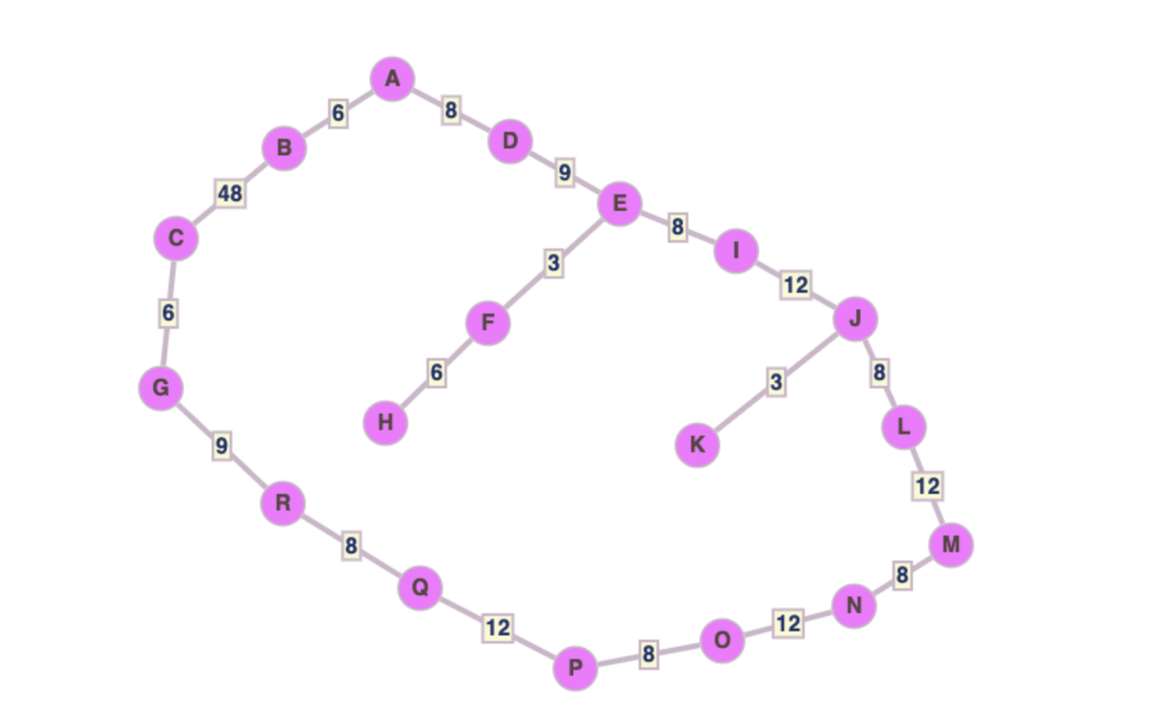

**Figure 3:** Undirected graph representing maze problem in the form of undirected graph. This data structure is used in Iterative Deepening A-star Algorithm coding algorithm.

**Heuristic Design as per the above graph:**

H(n) = {

'A': 60,

'B': 54,

'C': 6,

'G': 0,

'D': 68,

'F': 80,

'H': 86,

'E': 77,

'I': 85,

'K': 80,

'J': 77,

'L': 69,

'M': 57,

'N': 49,

'O': 37,

'P': 29,

'Q': 17,

'R': 9

}

**Figure 4:** Further simplifying the Above graph to connect the single path via one edge JG and construction of adjacency matrix according to simplified graph.

**Adjacency Matrix for Hill Climbing algorithm.**

